Parth Kataria (NUID - 002964611)

Assignment 3

Part 1

Repeat

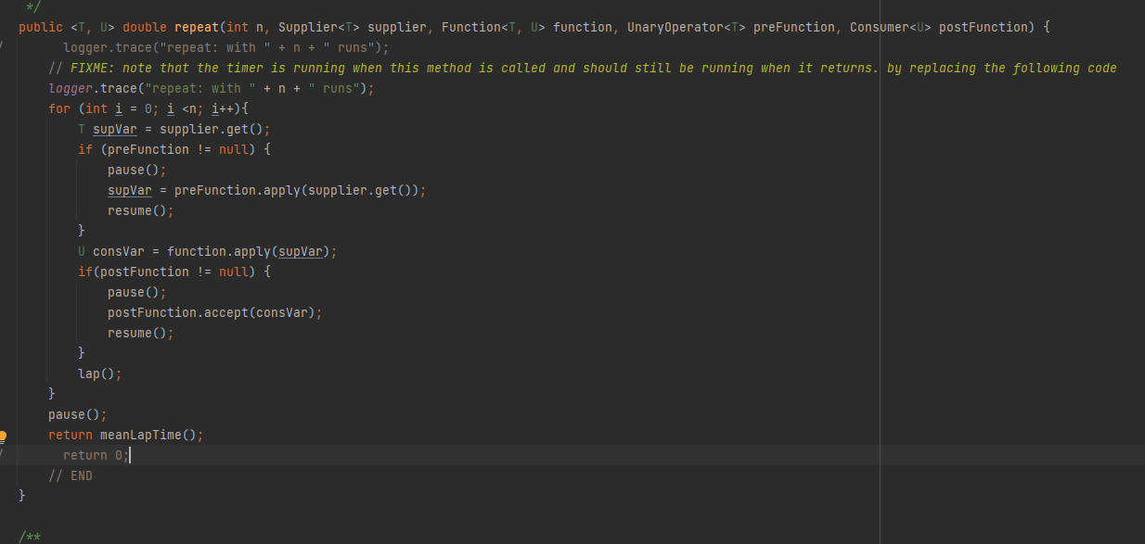

getClock

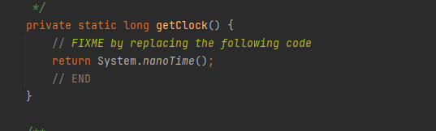

toMillisecs

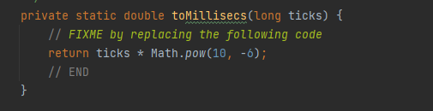

Part 2

Insertion Sort

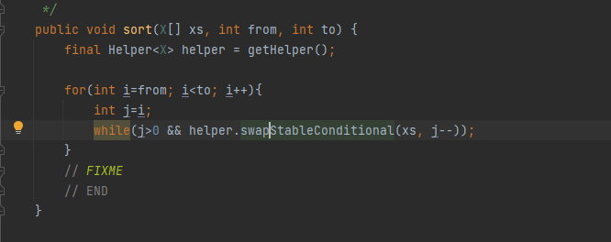

Part 3

Main class

Code

Part 1



Part 2



Part 3



Test Cases

Part 1 Timer Test

Benchmark Test

Insertion sort test

Observations

1 Partial sorted array

Slope is approximately 2

When we double the size of array, the time taken increases approximately by a factor of 4.

The order of growth is quadratic

2 Reverse sorted array

Slope is approximately 2

When we double the size of array, the time taken increases approximately by a factor of 4.

The order of growth is quadratic

3 Ordered array

The time for sorting the array increases slightly when the size of array increases.

The order of growth is linear

4 Randomly sorted array

Slope is approximately 2

When we double the size of array, the time taken increases approximately by a factor of 4.

The order of growth is quadratic

Conclusion

The time taken for sorting different arrays in ascending order is

Ordered Array > Partially Ordered Array > Randomly Ordered Array > Reverse Ordered Array

Excel for observations

